Shifty Duels [tbc]

<1.0>

Konstantin Schaper  
David Kuehlmann  
Alexander Hoffmeister

Video Game Design (CGP603)

Unit Lead: Christian Brindley

**DELETE SECTIONS IF THEY DO NOT APPLY TO YOUR GAME E.G. MONETIZATION  
(delete this message before hand-in)**

Concept Document 4

Game Goals 5

Story Overview 6

Game Controls 7

Technological Requirements 8

Title/Start Screen 9

Game Flowchart 10

Loading Screen 11

Game Camera(s) 12

HUD System 13

Player Character(s) 14

Player Metrics 15

Player Skills 16

Combat 17

Health 18

Scoring 19

Universal Game Mechanics 20

Game Levels 21

Monetization 22

Appendix(es) 23

# Concept Document

**Game Name:** Shifty Duels [tbc]

**Genre:**. Turn-Based 1on1 Arena

**Description:**

Shifty Duels is a turn-based, one versus one arena game that is played on a square grid.

The game either ends by one player dying or when a set number of turns have been played. The players gain points for dealing damage to the opponent, healing themselves or taking secondary objectives. The player with the most points at the end of the game wins.

The matches take place on floating debris in space with varied terrain. At the end of every turn the terrain randomly shifts in height, so the player has to adapt on the fly.

**Game features:**

* 1vs1 matches
* Isometric on a square grid
* Constantly shifting surroundings
* Variety of characters
* Interesting array of abilities for each character
* Different ways of winning the game

**Resources:**

* Unity (+ MonoDevelope/Visual Studio)
* Photoshop
* 3dsMax
* Audacity
* Trello
* GitHub (+ SourceTree)
* MS Office

# Game Goals

Our game is a turn-based multiplayer arena, the goal is to either kill your opponent or to have the most points at the end. The players spawn on opposing sides of the maps. Both have a hero that has several skills at their disposal, clever use of those skills is the key to victory.   
The game will be played on a square grid of tiles and the main feature of the game comes into play at the end of each turn, at this point the height of the individual tiles changes changing the look of the arena.   
As the game starts both player will find their heroes on opposite sides of the arena. Each player will have a turn consisting of moving his character and attacking his opponent if he wants to or is able to.  
To do this he has an array of four different abilities, that can target the environment, himself or the enemy. Use of these abilities consumes resources and they will incur a cooldown.   
After both players had their turn, the height shift comes into play. This mechanic will change the height of the individual tiles of the arena. This may block line of sight need for abilities or attacks or open new ones.   
The game will end when one player kills the opposing players hero, thus winning the game.

The game will be developed in Unity and be playable on PC.

# Story Overview

No direct story involved in the gameplay is planned for the game. The game is solely a multiplayer arena and does not focus on storytelling in any sort of way.  
A short “backstory” of the arena would be the following:

The setting is an abandoned space station that has accumulated a lot of space debris. While no organic life exists here, old robots from the stations golden days still roam the it. These robots fight for resources to maintain their mechanical bodies. Made all the harder by the ever shifting properties of the debris and the haywire leftover controls of the station.

# Game Controls

The game is played on a square grid. Everything can be controlled with the mouse, key bindings for abilities and menu.

Movement is done by clicking the character then choosing move and clicking where you want to move inside the shown move radius.

After that the player can use skills, by either using a hot key or clicking the skill, every skill has a radius where it can be used.

# Technological Requirements

The game will be done in Unity.

It will need at least the following requirements

* Windows XP SP2+
* Graphic card: DX9 or DX11 with feature level 9.3 capabilities
* CPU: SSE2 instruction set support

# Title/Start Screen

**Start screen:**

The start screen will have a number of option these are: Play, Options and Exit

**Options:**

The options provide the possibility to change various game settings such as screen resolution and adjusting audio levels.

**Play screen:**

Here the player can choose his hero and host or join a custom game.

# Game Flowchart

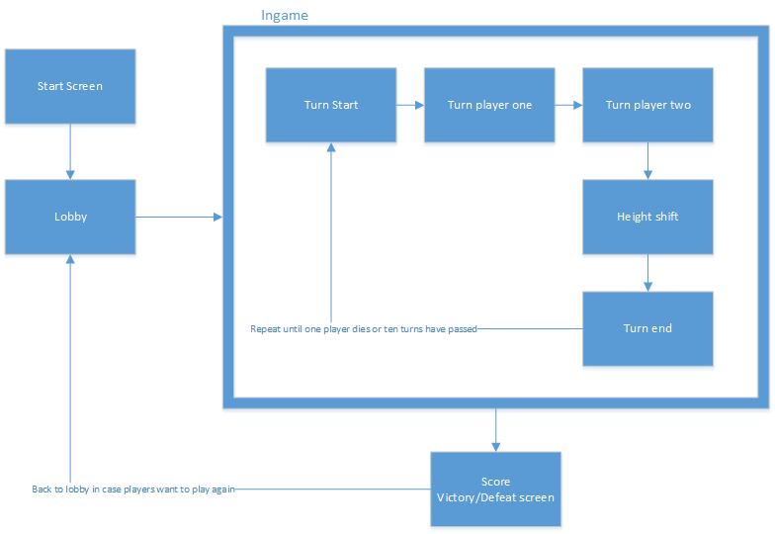

# Loading Screen

The Loading screen will, where it is needed, show an illustration of the arena.

# Game Camera(s)

The camera will be isometric, top down, focused on the map rather than being focused on the players hero. It can be centred on the hero by tapping “SPACE”. It can be moved by using the arrow keys or moving the mouse to the screen borders.

# HUD System

The HUD will contain a number of elements necessary for the game. Since the player control a hero it is imperative that they know the status of their hero at all times. As such we will have displays for health, action points and skills. All of this will be in the bottom centre of the screen.

In addition the player will be provided with a mini map of the arena. It will be located in the bottom right corner.

In the top middle of the screen the score will be shown.

# Player Character(s)

There is no singular player character instead the player can choose a predefined hero at the start of each match.

# Player Metrics

Health, when this stat goes to 0 the hero dies.

Energy, needed to use skills and move around the map. Regenerate each round.

Movement distance, determines how far the hero can move each turn. Movement costs a small amount of energy.

For the prototype hero it would be as follows:

|  |  |
| --- | --- |
| **Health** | 500 |
| **Energy** | 200 |
| **Energy/Round** | 100 |
| **Movement distance** | 5 |
| **Energy cost per tile** | 6 |

# Player Skills

Since we do not have a single player this will be a list for a prototype hero.

Turret Hero [development name]:

Skill 1:

Place a turret, within a defined radius, on the map.

If the turret is already placed move it to a new location instead.

Skill2:

Both the character and the turret shot their weapons at the targeted location.

Skill 3:

Pushes all other characters away from the character and the turret.

# Combat

Combat will mostly be either attacking a target or using a skill. In both cases after choosing the respective action an attack radius will be shown to show where you can attack or use a skill. Confirm simply by clicking the target.

# Health

Health will be tracked as a simple health bar, when falling below a certain percentage a sound effect will be played and the bar will turn from green to yellow.

Should health fall to 0 at any point the hero dies and loses the match.

# Scoring

At the moment the score will be directly derived from damage dealt. If a match goes too long the winner will be the one with the higher score after a set amount of rounds.

# Universal Game Mechanics

The important mechanic for this game is the height shift mechanic after each turn.

An algorithm iterates over the playing field and lowers or elevates all tiles based on the elevation of their neighbouring tiles. This is to prevent player from getting stuck. This mechanic provides a changing field of battle with shifting line of sights and eventually height boni for the heroes.

# Game Levels

The will be one level which will be the arena. It would be a derelict space station and debris.  
The galaxy and a planet as a backdrop. Music should be mainly in the background. Soundeffects need to be clearer, as they underscore the abilities.

# Monetization

The game will be a one time purchase. Further money could be made by selling DLCs containing new maps and heroes.

# Appendix(es)

This is the place where long lists go, including player animations, enemy animations, sound effects, music, cutscenes scripts, in-game text, and VO scripts.

This is where your task list should be placed.

This is where your Asset list will be.

You should break this section up in a readable manner using sub-headers ect.

Place list of textures needed.